Physical Science

Guide to Accessing Online Student Textbooks

1. Browse to the following website: <http://www.glencoe.com/ose/index.html>
2. Enter the Access Code - F18BCD5F5B

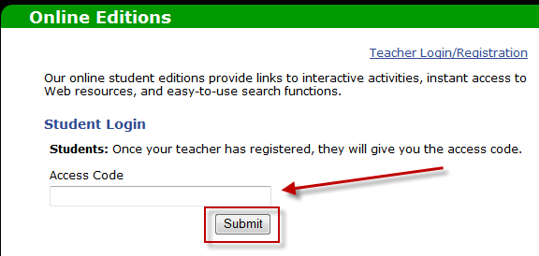

1. Enter the following access code

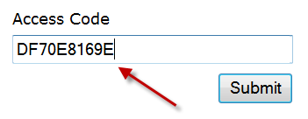

1. Click the Submit button

